COMBINED STATE BINDER GROUP AGENDA

October 25, 2022
Virtual – Microsoft Teams Meeting

I. CSBG Members and Suppliers (9:00 am – 10:30 am or earlier?)

- Welcome and Introductions
  - Present

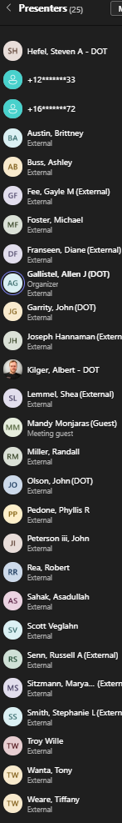

  - Also Present
    - Iowa room – Jon, Ken, Stacy
    - No ND at beginning, Jeff Herman and Joe Davis added at 9:30
    - Phone is Angie Peifer PRI (lab), Joe Hannaman McNamara (contractor)

- Questions and concerns with CSBG program, updates for 2023
  - Updates for 2023 Certification Program (open document for viewing)
    - Changes for next year will be listed at the beginning of the document.

  - Round Robin Update
    - Second sample in progress
    - Still looking to do the third sample towards the end of 2022
    - Next year – sample 1st material has been procured, planned schedule of March, June, and September
- Issues seen in 2022?
  - States
    - MN: 5 failed samples out of 500 tested ~ 1%.
    - IA, SD, WI all good
    - NE, softer material this year, mass loss is creeping up
          - Mandy (Ergon), -34 would drive it
        - ND, going well. Have seen some issues with Jnr diff
  - Suppliers
        - Asad Sahak: RTFO mass loss is higher in project samples (more than 0.5% this year), and lower stiffnesses on BBR (<200). Softer material than previous years.
- Old Business
  - Testing Frequency – we went to 3x / year for Solubility, Flash, and Brookfield. Certification document will be updated for 2023
- New Business
  - Standard Harmonization – AASHTO methods are specified by the program, unless there is specific mention by email with note made on the website, method changes will be adopted by the CSBG as changes get made to get AASHTO and ASTM methods to match - AASHTO/ASTM Task Force for Asphalt Standards Harmonization (TFASH)
  - Scott Veglahn, are states considering using delta Tc or ABCD data?
    - No: MN, WI, NE
    - IA may use Delta Tc for Performance Testing component
    - PRI has ran the testing
- Other / open discussion
  - Robert Rea E+++ high polymer grade, any issues making it
    - MN used HIMA in research
    - IA has E+ spec for HP thin overlay. Some issue getting through screed, too stiff, too cold. Spec’d at 90% recovery

